**Leader Overview**

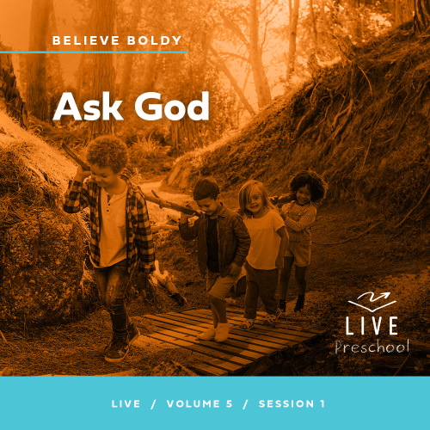

**Volume Overview**

**Believe Boldly**

*The gospel message is shocking to many, shocking because of its implications. God has made himself known to us and promised to place His Spirit into our heart. We have been given direct access to Him. The Bible encourages us to come to Him with boldness. Our boldness in approaching Him is not from our words or our achievements. Instead, it’s based on God’s promises. So we ask, remembering His power and faithfulness. And we encourage those around us to do the same. Believe boldly.*

**Session Overview**

**Ask God**

*In this* **Live** *session, preschoolers will learn to call out to Jesus with boldness when they need Him. They will see how Bartimaeus kept yelling for Jesus’ help even when others tried to silence him. Preschoolers will discover that Jesus is always there for us when we need Him.*

**Bible Lesson**

Blind Bartimaeus Calls to Jesus for Healing

[Mark 10:46–52](https://ref.ly/logosref/Bible.Mk10.46-52)

**Faith Fact**

I will pray boldly.

**Faith Verse**

[1 Corinthians 16:13–14](https://ref.ly/logosref/Bible.1Co16.13-14) (NLT)

Be on guard. Stand firm in the faith. Be courageous. Be strong. And do everything with love.

**Preparing for the Session**

**Leader Preparation Time: 20–25 Minutes**

|  |
| --- |
| ***You Will Need***  ***Preservice Activities***  *• Toys*  *• Toy police car, firetruck, or ambulance*  *• Stackable snacks (cheese cubes, crackers, etc.)*  ***Large Group***  *• Bible*  *• Worship songs (Song suggestions: “Living Color” Lyric Video by Elevation Church Kids; “Brave” Motions Video by Saddleback Kids Worship; “Little Life” Lyric Video by Hillsong Kids; “Never Be Shaken” Lyric Video by New Life Kids*  *• For groups not using a phone or tablet only, add:*  *• Projector or TV*  *• Laptop*  *•* ***Countdown60 Video****–60 seconds*  *•* ***Faith Fact Sound*** *video (bell ringing)*  *•* ***Faith Fact Slide***  *•* ***Faith Verse Slide***  *•* ***Faith Verse Video***  *•* ***Bible Lesson Video A***  *•* ***Bible Lesson Video B***  ***Small Group***  *•* ***Small Group Activity Page****, one per kid*  *• Pencils or pens, one per kid*  *• Sheets of paper, forty sheets per group (used paper or newspaper works for this activity)*  *• Floor-safe tape*  *•* ***Countdown60 Video****–60 seconds*  *• Clear large glass or pitcher of water, one per group*  *• Alka Seltzer® tablets, two to four per group*  *To access session content and videos from a computer, visit:* [*BibleEngagementProject.com/downloads*](https://bibleengagementproject.com/downloads) |
| ***Getting Ready***  ***Preservice Activities***  *• Set out toys and snacks.*  ***Large Group***  *• Download videos and slides if needed.*  *• Select worship song(s) and have them ready to play.*  ***Small Group***  *• Print copies of the* ***Small Group Activity Page****, one per kid.*  *• Tape a line down the center of the playing area.*  ***First time leading* Live *for Preschool? Check out the*** [**Facilitator Guide**](https://0b769b0ed3569ef9d18b-f88d8272f61086866d50d048b43ef630.ssl.cf2.rackcdn.com/sites/biblengagementproject/Listen_Facilitator_Guide.pdf)**.** |

**Preservice Activities**

*See what’s needed at the beginning of the session.*

**Bible Story Warm-Up**

Hi, friends! I’m so excited that you’re here today! Have you ever been riding in the car and you heard the noise of a firetruck, police car, or ambulance? Can anyone tell me what sound they make? *(Group response)* That’s right, they make a “woo-woo” *(mimic siren sound)* sound when they’re driving. They make that sound to get the attention of other people on the road. When other drivers hear the sirens, they are supposed to move out of the way.

Why do you think other cars should move out of the way?

What is something you do to get someone’s attention when you need help?

Who is someone who helps you?

Next time I need to get someone’s attention, I’ll definitely try some of your ideas. In today’s Bible story, we’ll learn about someone who needed help and what he did to get a very important Person’s attention. I can’t wait to learn about this with you.

**Snack**

**Stackable Snack (Cheese cubes, crackers, etc.)**

The Faith Verse that we’ll learn later today is about being brave. We don’t have to back down; instead, we can stand firm. Does anyone know what it means to “stand firm”? *(Allow responses.)* When we stand firm, it means we don’t go backwards, fall down, or give up. Can you show me how you can stand firm? Stand up as tall as you can. *(Group response)* Great job! God is on our side, and He will help us be bold and brave when we ask Him.

Let’s sit down and enjoy our snack. Today’s snack will help us practice standing firm. When you get your snack, I want you to see how many pieces you can stack up. Count how many pieces are standing firm in your stack. When it falls down, you can eat your snack.

• *Give the snack to the kids.*

• *Celebrate kids as they stack up their snacks.*

**Free Play**

*Any extra time can be spent playing with toys.*

**Transition**

*A few minutes before service begins have kids make their way to the large group area and sit in their designated areas.*

**Large Group**

**25 Minutes**

*See what’s needed at the beginning of the session.*

**Introduction**

Hi, kids! We’ll have a great time learning from God’s Word today. *(Hold up the Bible.)* If you’re excited to be here, raise your hand! *(Group response)* Me, too! Today, we’ll learn that we can ask Jesus for help even when others discourage us. We’ll hear about a man named Bartimaeus who couldn’t see, and he wanted Jesus’ help. There was a big crowd of people around Jesus, so Bartimaeus wasn’t close to Him. Bartimaeus believed Jesus could heal him, but first he had to get Jesus’ attention.

**Faith Fact**

The people around Bartimaeus weren’t helping him get Jesus’ attention. They wanted Bartimaeus to be quiet. He knew he was going to have to do it on his own. What would you do to get Jesus’ attention? *(Allow responses.)* Good thinking! Bartimaeus shouted boldly to Jesus. We can talk to Jesus boldly when we need His help. That’s why our Faith Fact today is **I will pray boldly.**

• *Show the* ***Faith Fact Slide.***

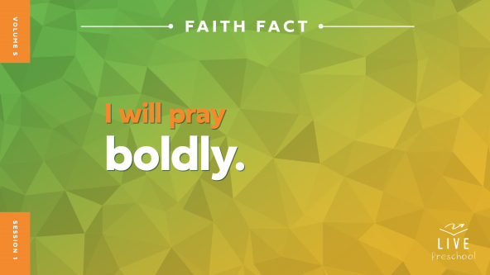

The first time we say it, let’s whisper it quietly. **I will pray boldly.** *(Group response)* Awesome! Now, let’s do what our Faith Fact says and shout it boldly. Ready to shout it? **I will pray boldly**.

**Bible Time**

One of my favorite things we do together is learn about Jesus from the Bible. We have a special friend named Lizzy who helps us do that. Let’s see what she’s doing.

• *Play* ***Bible Lesson Video A****.*

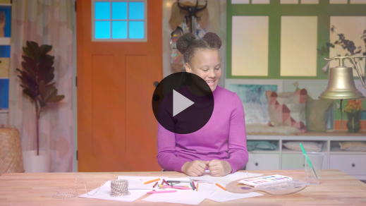

I’m so glad Grandpa and Lizzy gave us a little time to think. Let’s worship God for a few minutes while we think. Then, I’ll ask you what you think is going to happen next in our Bible story.

**Worship**

One way we show Jesus our love is by learning about Him in the Bible. Another way we can show Him is through praise and worship. When we worship, we get to focus on Jesus and tell Him that we love Him.

**Praise**

Who wants to follow Jesus closely like the crowd in our story? March in place. *(Group response)*

Who wants to thank Jesus for hearing us when we call out to Him? Cup your hands around your mouth and shout, “Jesus!” *(Group response)*

Who wants to thank Jesus for loving us? Wave your hands up high. *(Group response)*

**Sing**

Let’s worship Jesus and show Him we love Him by singing some songs about how amazing He is.

• *Lead the kids in singing one or two songs. See song suggestions at the beginning of the session.*

**Prayer**

Now, let’s bow our heads and pray.

|  |
| --- |
| *Dear Jesus, thank You for how great You are. You are always ready to help us when we need it, and we praise You for that. Amen.* |

**Bible Time cont’d**

• *Start* ***Bible Lesson Video B*** *and pause on the image of the two choices.*

Grandpa and Lizzy are coming back soon. Let’s think about what happens next in our Bible story. Can you put on your thinking caps? *(Demonstrate.) (Point to “ear” graphic.)* If you think Bartimaeus listened to the crowd and went silent, cover your mouth with your hands and be super quiet. *(Point to “microphone” graphic.)* If you think Bartimaeus kept calling to Jesus, put your hands around your mouth and pretend to shout to Jesus. Show me your answer. *(Group response)* Let’s find out if you’re right by checking in with Lizzy and Grandpa.

• *Play* ***Bible Lesson Video B.***

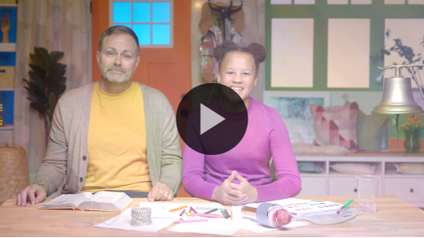

Do you think Bartimaeus made the right choice to keep calling boldly to Jesus? *(Group response)* I do! It took bold faith to ignore the crowd telling him to be quiet. He was right to ask Jesus for help, and Jesus wanted to heal him.

**Response Time**

*Play a worship song quietly.*

Let’s respond to what we’ve learned today. Let’s think about something we need from Jesus today. Maybe someone in your family is sick. Maybe someone has been mean to you, and you want them to stop. We can pray boldly about a lot of things. When you’ve got something in mind that you want to pray to Jesus about, lift your hand in the air. *(Pause while kids respond.)* Let’s pray boldly together.

• *Have the kids repeat phrases of the prayer after you.*

|  |
| --- |
| *Dear Jesus, You want me to pray boldly to You. I need Your help with something important. Help me to trust You. Please give me what You know I need. Thank You. Amen.* |

**Faith Verse**

Our Faith Verse tells us to be strong and brave when we’re facing hard things like what we just prayed about. When we learn Bible verses from God’s Word, we can build our faith in Him. Let’s say our Faith Verse and do the actions together.

[1 Corinthians 16:13–14](https://ref.ly/logosref/Bible.1Co16.13-14) (NLT)

Be on guard. Stand firm in the faith. Be courageous. Be strong. And do everything with love.

• *Show the* ***Faith Verse Video.***

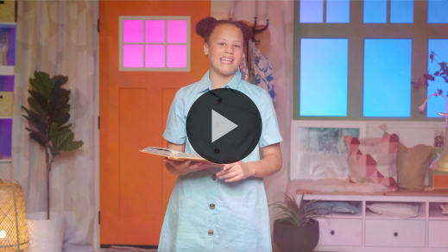

**1 Corinthians** *(hands at waist, spread apart, palms up and out)*

**16:** *(hands together like a clap)*

**13–14** *(hands opened to “book”)*

**Be on guard.** *(fierce face and cross arms in X in front of body)*

**Stand firm in the faith.** *(jump and land with feet spread apart)*

**Be courageous.** *(salute)*

**Be strong.** *(flex bicep muscles)*

**And do everything with love.** *(place hands over heart)*

Great job, friends! Keep practicing our Faith Verse at home, and we’ll say it again when we’re together.

**Closing**

Did you have a great time exploring our Bible story today? *(Group response)* Bartimaeus showed us how to keep calling out to Jesus when we need Him. We worshipped Jesus by singing and praying. We learned a Faith Verse from the Bible about being strong. Our Faith Fact helped us remember that we can be bold when we call out to Jesus.

• *Play the* ***Faith Fact Sound*** *video (bell ringing).*

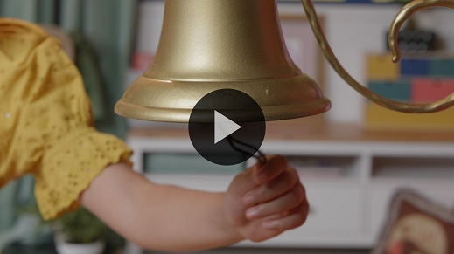

That sound means it’s time to say our Faith Fact one more time! **I will pray boldly**.

• *Show the* ***Faith Fact Slide.***



Let’s start crouched down in a ball *(demonstrate)*, and as we say it, we’ll get bigger and louder until we’re standing tall. Get down as low as you can. Ready? **I will pray boldly**. Great job! Let’s do it one more time! Start down low. *(demonstrate)* **I will pray boldly**.

**Dismissal to Small Groups**

Great job! Now it’s time to go to our circles where we’ll spend time in our very special small groups.

• *Dismiss the kids by groups.*

|  |
| --- |
| ***Leader Tip:*** *This can be done by assigning color teams or by age groups. Note that some young preschoolers may not know their age. Using a colored sticker, jersey, or wristband will help separate the kids and help identify their small groups.* |

**Small Group**

**25 Minutes**

*See supplies and prep instructions at beginning of session or in each activity below.*

|  |
| --- |
| ***Leader Tip:*** *Small groups can alternate to each circle, or all groups can do each activity at the same time. If you choose to alternate, you will need at least one leader per circle.* |

**Circle 1**

**Group Connection**

**Pass the Prayer**

|  |
| --- |
| *No prep needed for this activity.* |

* *Have kids sit in a circle when they arrive to this activity.*

It’s always so much fun learning with you! Today, we’ve learned that we can pray bold prayers. We learned how Bartimaeus called to Jesus because he wanted to be healed. Bartimaeus didn’t keep his need a secret. Instead, he let everyone around know that he wanted Jesus to heal him.

I have a fun way to help us remember that we can pray bold prayers, too. Before we do that, let’s practice saying our Faith Fact together. Ready? *(Group response)* **I will pray boldly**. Perfect!

I’ll start off our game by giving *(insert name of kid to your right) a* high five and saying the first word of our Faith Fact. Then, that kid will give *(insert name of kid to the right of them)* a high five and say the next word. If you receive a high five with the word *boldly*, then I want you to share something that we can pray with you about. After you share a prayer request, you’ll high-five the person next to you and start the Faith Fact over again.

• *Allow kids to do this activity until everyone has had a chance to share a prayer need.*

• *Be ready with prayer suggestions (e.g., to have a good day, sleep well tonight, have fun at church) for anyone who has a hard time thinking of something.*

Those were some great prayer requests! I want to pray with you about them. Before we do that though, let’s say our Faith Fact all together. **I will pray boldly.** Awesome, now let’s pray.

• *Lead kids in prayer for needs they mentioned.*

**Circle 2**

**Activity Page Time**

**A-maze-ing Path**

|  |
| --- |
| ***You Will Need***  *•* ***Small Group Activity Page****, one per kid*  *• Pencils or pens, one per kid*  ***Getting Ready***  *• Print copies of the* ***Small Group Activity Page****, one per kid.* |

We can pray bold prayers to Jesus. That means we can talk to Him about the really important things in our life like Bartimaeus did. Remember that when he first tried to talk to Jesus, everyone told him to be quiet. Bartimaeus didn’t let that stop him. In fact, he got bolder and louder. Then, Jesus invited Bartimaeus to come to Him.

• *Hand out a copy of the* ***Small Group Activity Page*** *and a pencil to each kid.*

Let’s see if you can help Bartimaeus find his way to Jesus. Follow the path carefully all the way to Jesus. When you get to Jesus, shout our Faith Fact. **I will pray boldly.**

• *Give kids time to complete the* ***Small Group Activity Page*** *and assist them as needed.*

You did such a good job helping Bartimaeus get to Jesus. I’m glad you didn’t give up, and I’m glad Bartimaeus didn’t give up either because Jesus healed him that day.

**Circle 3**

**Feet-to-Floor Game Time**

**Be On Guard**

|  |
| --- |
| ***You Will Need***  *• Sheets of paper, forty sheets per group (used paper or newspaper works for this activity)*  *• Floor-safe tape*  *•* ***Countdown60 Video****–60 seconds*  ***Getting Ready***  *• Tape a line down the center of the playing area.* |

If you’re excited to play a game, let me hear you clap your hands. *(Group response)* Great! I love to play games, and today we have a super fun one to play. We’ll divide our group into two teams. Each team will be on one side of the line on the floor. *(Show kids the line.)* In a minute, I’ll hand each team twenty sheets of paper *(hold up papers)* to crumple into balls. Once all the papers are crumbled, the game will start.

Your job is to guard your side of the line the best that you can. When I say the words, “Be on guard,” you will try to throw all the paper balls to the other team’s side of the line. You must pay attention because the other team will be throwing paper balls to your side. If you’re ready to start, wave your hands in the air! *(Group response)*

• *Divide group into two teams.*

• *Hand out sheets of papers and give kids time to make tight paper balls.*

• *Play as many rounds as time allows.*

• *Start the* ***Countdown60 Video****-60 seconds and give kids time to play.*



• *During the activity, interrupt and practice the Faith Fact:* **I will pray boldly.**

• *Play the* ***Faith Fact Sound*** *video****.*** *Review the Faith Fact even if you can’t play the sound.*



Well, that was amazing! Everyone did such a good job guarding their side. That reminds me of the verse we’ve been learning. Let’s practice saying our Faith Verse together.

• *Lead the kids through the Faith Verse and actions.*

**1 Corinthians** *(hands at waist, spread apart, palms up and out)*

**16:** *(hands together like a clap)*

**13–14** *(hands opened to “book”)*

**Be on guard.** *(fierce face and cross arms in X in front of body)*

**Stand firm in the faith.** *(jump and land with feet spread apart)*

**Be courageous.** *(salute)*

**Be strong.** *(flex bicep muscles)*

**And do everything with love.** *(place hands over heart)*

Great job! The best way that we can be prepared to stand firm in the faith is by learning God’s Word. Keep working hard to memorize your Faith Verse, and you’ll be ready to stand firm no matter what comes your way.

**Circle 4**

**Hands-On Learning**

**Bubbly Boldness**

|  |
| --- |
| ***You Will Need***  *• Clear large glass or pitcher of water, one per group*  *• Alka Seltzer® tablets, two to four per group*  *No prep is needed for this activity.* |

Today, we’ve learned that we can ask Jesus for big things when we pray. Our Faith Fact is about that. Who remembers what it is? *(Allow responses.*) That’s right, **I will pray boldly**. The awesome thing about prayer is that it’s not just us talking to Jesus, but He listens to us when we speak. He wants to talk to us, too. Like in our Bible story when Bartimaeus called to Jesus, Jesus called back to Bartimaeus.

It’s like this cup of water. *(Hold up or point to water).* Right now, it’s just a regular glass of water. It’s nothing too exciting. It’s just clear water like we see and drink every day. Our life can be that way when we don’t spend time talking to Jesus. But when we pray, it’s like putting something extra into the water. *(Hold up the Alka Seltzer tablets.)*

• *Unwrap the tablets and drop them into the water.*

Whoa! Look at all those bubbles! As soon as I dropped the tablet into the water, the bubbles started popping up. That’s what it’s like when we talk to Jesus. When we pray, things can change because Jesus hears us. These bubbles also remind me of how happy Jesus is when we spend time talking to Him. I love that we can talk to Him anytime, any day, and in any place. He is always there and always listening. Isn’t that amazing? *(Group response)*

**Dismissal**

• *Play the* ***Faith Fact Sound*** *video (bell ringing).*



• *Show the* ***Faith Fact Slide.***



I can’t believe it’s already time to go. Before we leave, let’s say the Faith Fact together one last time as loud as we can. Ready? **I will pray boldly.** Yes! Let’s not forget that we can always talk to Jesus and pray bold prayers! We can ask for really big things like Bartimaeus did when he asked Jesus to heal him. I had a great time learning more from God’s Word with you. See you next time!

• *Send home the* ***Small Group******Activity Page*** *with each kid.*

• *Remind parents that there are* ***Family Devotions*** *available on the app to do with their kid.*

• *Tell everyone the date and time for the next session.*